# Information Visualization

# CHECKPOINT III: Visualization Sketch

G08-A

**1. Visual Encoding**

Description of the visual encoding you have selected for each data type.

* Course Unemployment % – Encoded as **position** in vertical axis
* University Unemployment % - Encoded as **circle area**
* Year – Encoded as **position** in horizontal axis
* Course/University Name – Encoded as **colours “hue”** and **position**
* 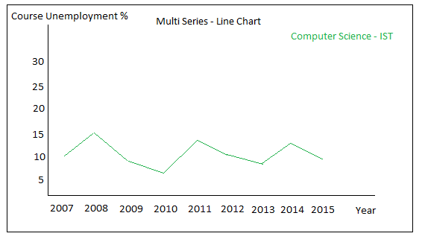Entry Grade – Encoded as **position** in horizontal axis

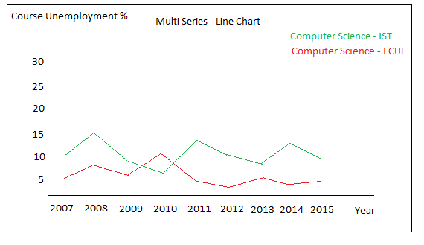**2. Idiom and Tasks/Question**

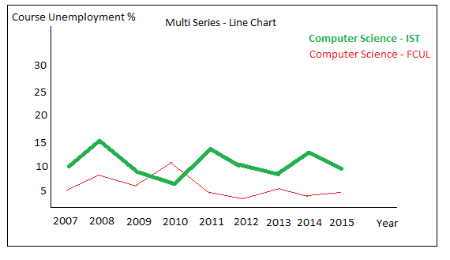

Image 1 – (Top Left) Line chart presenting unemployment of one course. (Top Right) Due to interaction we can add more courses to the line chart and compare them. (Bottom) It’s possible to select a course line and highlight the course in the other views ex: Highlight the course dot in the next presented idiom (Image 2 – Bottom).

- **Task 1**: Query->Compare - Compare the unemployment (%) of different courses (regardless of course conclusion year of the graduates). **(Image 1 - Top Right)**

- **Task 2**: Analyze->Consume->Present – Present the information about unemployment (%) from a specific course graduates across time. **(Image 1 - Top Left)**

- **Question 1**: Does Computer Science graduates in IST have more unemployment, in 2015, than Computer Science in FCUL? And in 2007? **(Task 1) (Image 1 - Top Right)**

- **Question 2**: Is Computer Science in IST having less unemployed graduates in last year’s? **(Task 2) (Image 1 - Top Left)**

- **Question 3**: What was the year which had less unemployed people from Computer Science in IST? **(Task 2) (Image 1 - Top Left)**

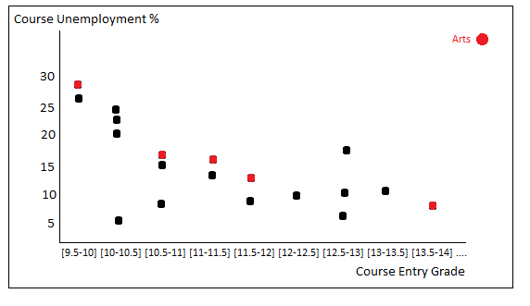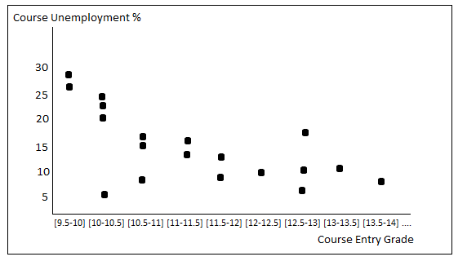

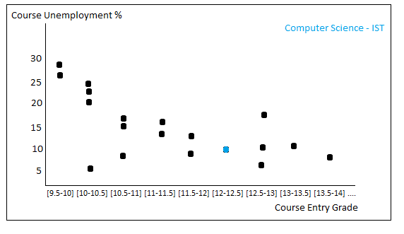

Image 2 – (Top Right) Scatter plot highlighting the course from a specific area due to interaction in area’s idiom. (Bottom) Scatter plot highlighting a specific course (due to interaction) selected in course’s line chart.

**New Opportunity**: Catch outlier’s courses to see if there is a specific course in an area with higher unemployment that has a very low unemployment. This is easy because the course’s area unemployment view will be “connected” with this one.

**New Opportunity 2**: Catch the unemployment/entry grade correlation for courses from the same area. This is possible due to possibility of select an area in courses area view and highlight here (Image 2 – Top Right).

- **Task 4**: Consume->Present – Relation between minimum entry grade and unemployment (%). **(Image 2 - Top Left)**

- **Question 4**: Where the unemployment will be higher? In a course with 14 minimum entry grade or one with 17? (Task 4) **(Image 2 - Top Left)**

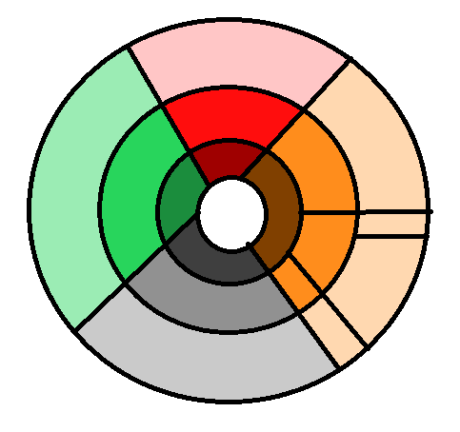

Design (2.7%)

Artes e Humanidades (12%)

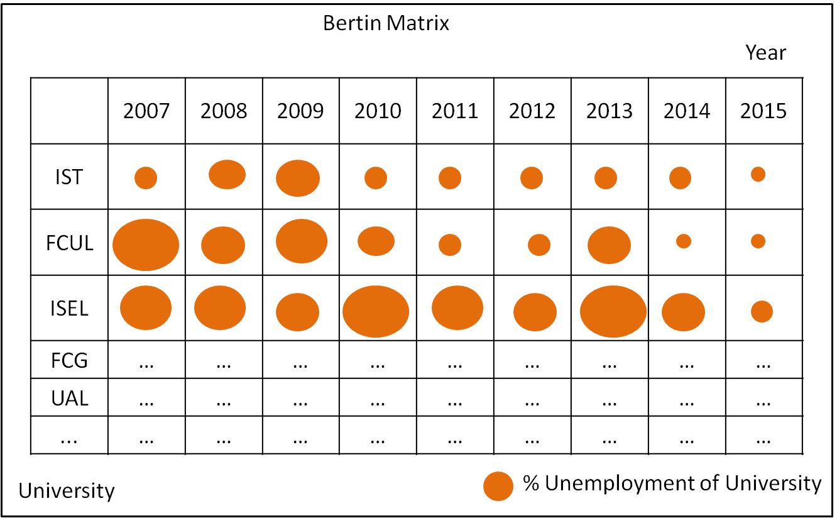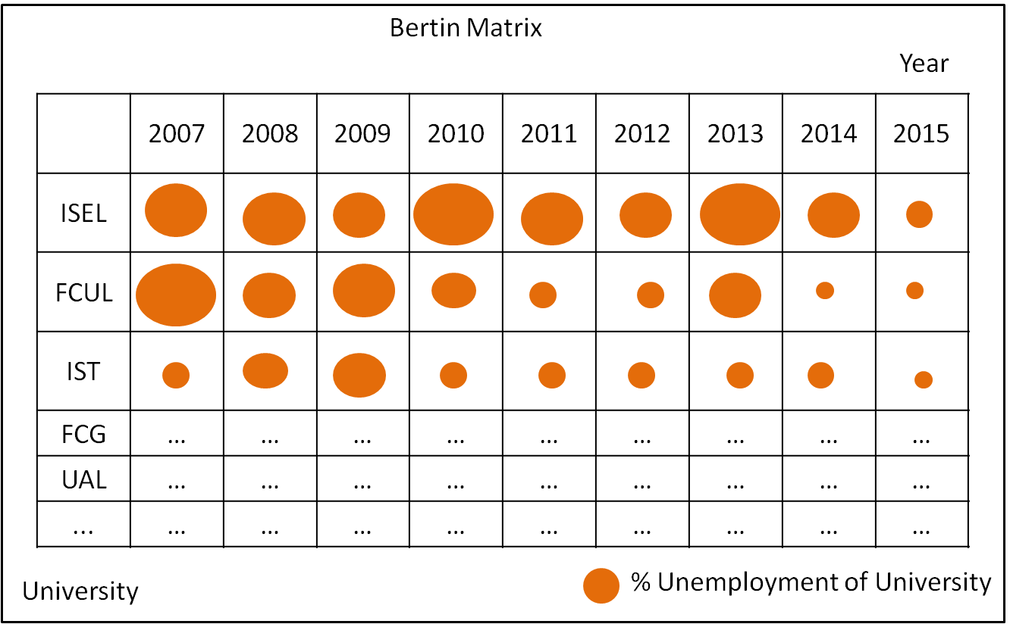**New Opportunity**: Sort the universities in ascending and descending order to give user both perspectives of the data.

Image – (Left) Universities unemployment ordered in descending order. (Right) Universities unemployment ordered in ascending order.

**New Opportunity 2**: It will be possible to choose a particular university to see in the top of the matrix using interactivity, and the selection of a course (Image 1 – Bottom) will put that course university in the top and highlighted.

- **Task 3:** Query->Identify – Identify the university with more unemployment (%). **(Image 3 - Left)**

- **Question 5:** What is the university with more unemployment? **(Task 3) (Image 3 - Left)**